**Practical 5**

|  |  |  |  |
| --- | --- | --- | --- |
| |  |  |  | | --- | --- | --- | | |  |  | | --- | --- | | |  | | --- | | **Aim:** Write a VHDL Code to implement JK Flipflop | | |   **Code:**  library IEEE;  use IEEE.STD_LOGIC_1164.ALL;  entity JK_FF is  Port ( clk : in STD_LOGIC;  rst : in STD_LOGIC;  J : in STD_LOGIC;  K : in STD_LOGIC;  Q : out STD_LOGIC;  Qb : out STD_LOGIC);  end JK_FF;  architecture Behavioral of JK_FF is  signal q1:std_logic:='0';  signal q2:std_logic:='1';  begin    process(rst,clk,J,K)  begin  if (rst='0') then  Q<='0';  Qb<='1';  elsif(rising_edge(clk)) then  if(J = '1' and K = '0')then  q1<='1';  q2<='0';  elsif(J = '0' and K = '1') then  q1<='0';  q2<='1';  elsif(J = '0' and K = '0') then  q1<= q1;  q2<=q2;  elsif(J ='1' and K ='1') then  q1<= q2;  q2<= q1;  end if;  Q<=q1;  Qb<=q2;  end if;  end process;    end Behavioral; |
|  |

**RTL DIAGRAM:**

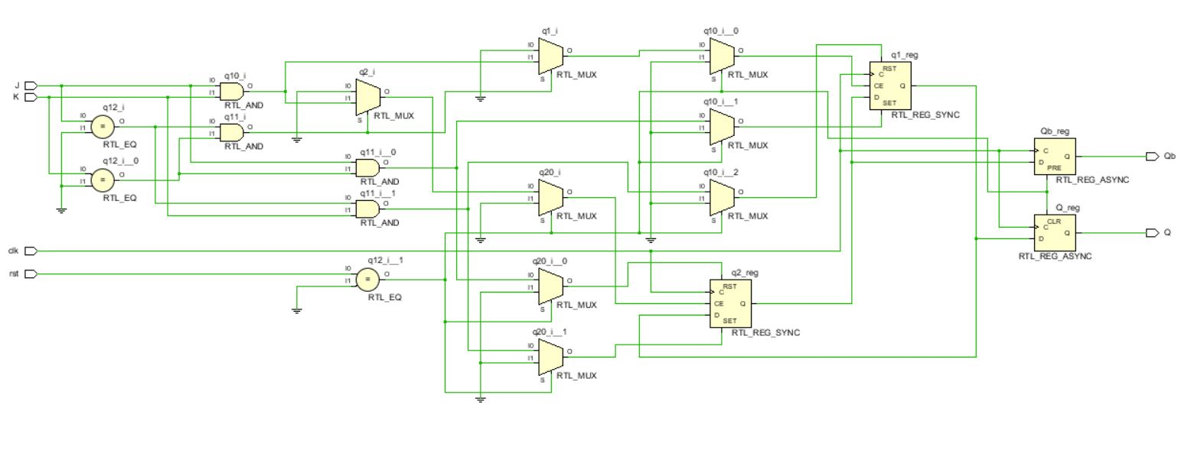

**Test bench Code :**

library IEEE;

use IEEE.STD_LOGIC_1164.ALL;

entity Tb_JK_FF is

-- Port ( );

end Tb_JK_FF;

architecture Behavioral of Tb_JK_FF is

component JK_FF is

Port ( clk : in STD_LOGIC;

rst : in STD_LOGIC;

J : in STD_LOGIC;

K : in STD_LOGIC;

Q : out STD_LOGIC;

Qb : out STD_LOGIC);

end component JK_FF;

signal clk,rst,J,K,Q,Qb:std_logic;

begin

x1:JK_FF port map(clk,rst,J,K,Q,Qb);

process

begin

clk<='1';

wait for 4ns;

clk<='0';

wait for 4ns;

end process;

process

begin

rst<='0';

wait for 10ns;

rst<='1';

J<='0';

K<='0';

wait for 10ns;

J<='1';

K<='0';

wait for 10ns;

J<='0';

K<='1';

wait for 10ns;

J<='1';

K<='1';

wait for 10ns;

end process;

end Behavioral;

**SIMULATION WAVEFORM :**

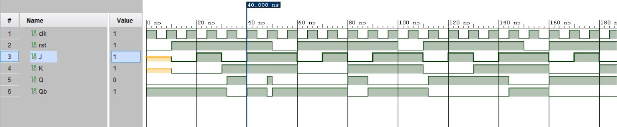

**SYNTHESIS SUMMARY:**

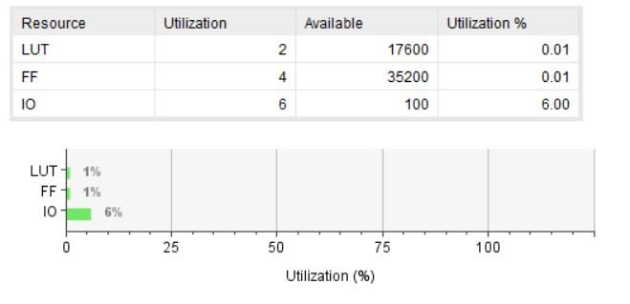

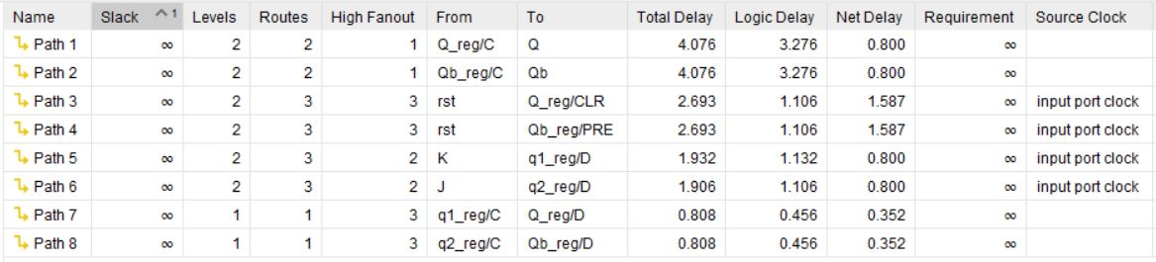

Maximum Combinational Delay: 4.076nSec

|  |  |  |  |
| --- | --- | --- | --- |
| |  |  |  | | --- | --- | --- | | |  |  | | --- | --- | | |  | | --- | | **Aim:** Write a VHDL Code to implement D Flipflop | | |   **Code:**  library IEEE;  use IEEE.STD_LOGIC_1164.ALL;  entity D_FF is  Port ( clk : in STD_LOGIC;  rst : in STD_LOGIC;  D : in STD_LOGIC;  Q : out STD_LOGIC;  Qb : out STD_LOGIC);  end D_FF;  architecture Behavioral of D_FF is  component JK_FF is  Port ( clk : in STD_LOGIC;  rst : in STD_LOGIC;  J : in STD_LOGIC;  K : in STD_LOGIC;  Q : out STD_LOGIC;  Qb : out STD_LOGIC);  end component JK_FF;  signal Db:STD_LOGIC;  begin  Db<= not D;  x1:JK_FF port map(clk,rst,D,Db,Q,Qb);  end Behavioral; |
|  |

**RTL DIAGRAM:**

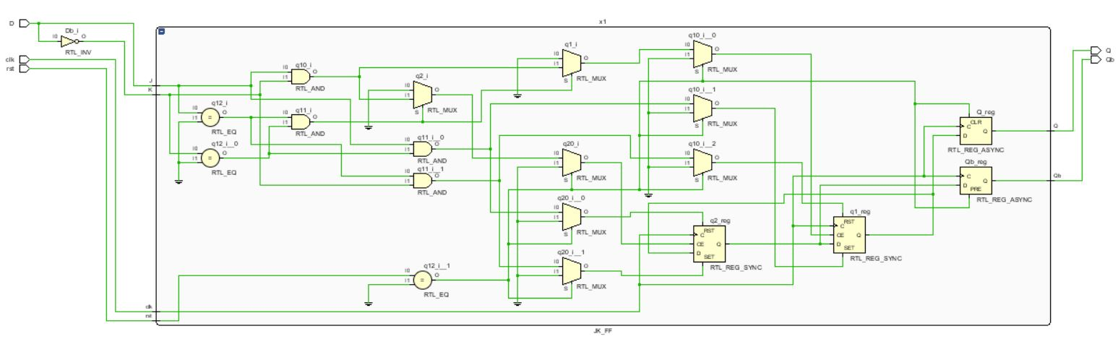

**Test bench Code :**

library IEEE;

use IEEE.STD_LOGIC_1164.ALL;

entity Tb_D_FF is

-- Port ( );

end Tb_D_FF;

architecture Behavioral of Tb_D_FF is

component D_FF is

Port ( clk : in STD_LOGIC;

rst : in STD_LOGIC;

D : in STD_LOGIC;

Q : out STD_LOGIC;

Qb : out STD_LOGIC);

end component D_FF;

signal clk,rst,D,Q,Qb:std_logic;

begin

x1:D_FF port map(clk,rst,D,Q,Qb);

process

begin

clk<='1';

wait for 5ns;

clk<='0';

wait for 5ns;

end process;

process

begin

rst<='0';

wait for 10ns;

rst<='1';

wait for 50ns;

end process;

Process

begin

D<='0';

wait for 10ns;

D<='1';

wait for 10ns

end process;

end Behavioral;

**SIMULATION WAVEFORM :**

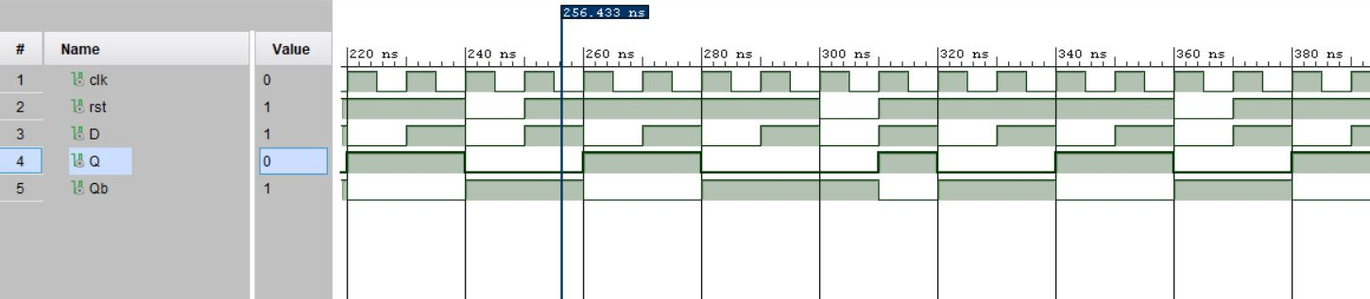

**SYNTHESIS SUMMARY:**

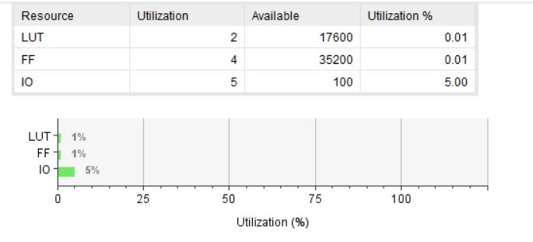

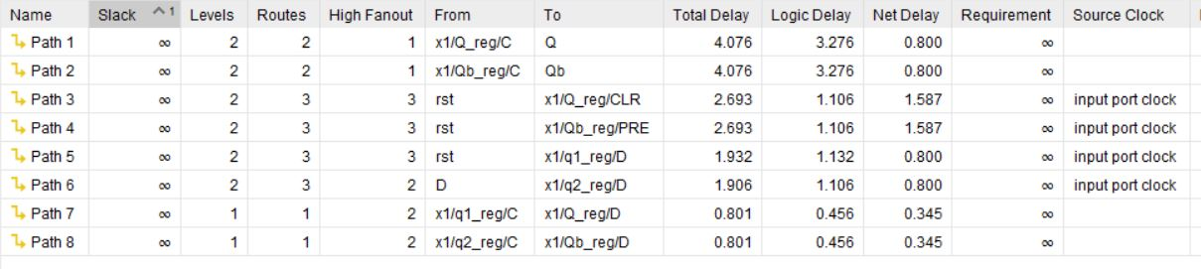

Maximum Combinational Delay: 4.076nSec